Title of the Abstract for the 19th ISGdR (do not exceed 100 characters including spaces)
Firstname Firstsurname^{1,*}, Secondname Secondsurname², Thirdname Thirdsurname²

¹ Department of Earth Science, Shimane University, Matsue, Shimane 690-8504, Japan
² Department of Geotechnical Engineering, Tongji University, Shanghai 200092, China
* Corresponding author. Tel: +81-70-3772-1906; E-mail: zilidai@shu.edu.cn

Please underline the name who will give the presentation.
Please send your Abstract to gjjzhy2021@163.com

Abstract
This is an example text template for the Abstract submission to the 15th International Symposium on Geo-disaster Reduction. The Abstract should be concise and self-contained, clearly stating main conclusions of your presentation. Please avoid scientific or engineering symbols, acronyms and bullets.
The submission should be typed single-spaced in 12-point type Times New Roman in Microsoft Word file (*.doc/*.docx). The length should be in one page.
The page format must be strictly respected as per Template Page Format. In particular, two columns formatting with column width of 77 mm and column spacing of 6 mm should be used. Page margins are: Top 40 mm; bottom 40 mm; Internal side 25 mm; External side 25 mm.
Only one figure is allowed either in greyscale or in color. It is possible to insert column-wide figure (half-page width) with maximum width of 77 mm and double-column-wide figure as well with a max allowed dimension of 170 mm. In any case, the max height is 100 mm. The following is an example of column-wide figure.

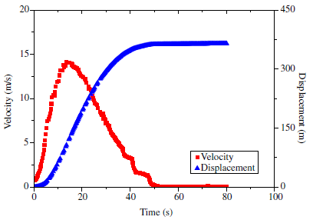
Fig. 1 Example of half page figure.

Acknowledgments
This work was supported by the National Basic Research Program of China (Program 973) through Grant No. 2017CB123456.

References
Aaron M (1999) The future of genomics. In: Williams H (ed) Proceedings of the genomic researchers, Boston, 1999.
Cascini LS, Cuomo M, Pastor G, Piciullo L (2014) SPH run-out modelling of channelized landslides of the flow type. Geomorphology 214: 502–513.

